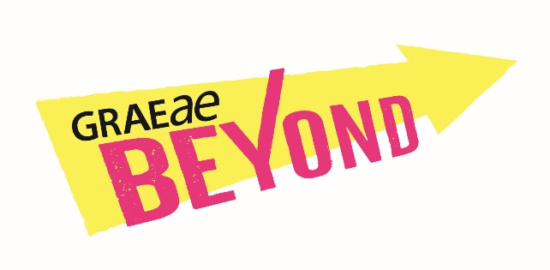**Beyond Artist Development Programme.**

**Information for Artists.**

Beyond is Graeae’s bespoke Artist Development programme, started in 2020 it has supported over 60 Deaf, disabled and neurodivergent artists in developing their careers, taking on new challenges & building successful connections.

*“I entered the programme an emerging artist and I am leaving a mid-career artist with a plethora of experience, connections and opportunities all stemming from this programme.” (Beyond artist)*

Beyond is helping to develop greater access to regional opportunities across England ensuring Deaf, disabled and neurodivergent artists are at the forefront of new and emerging work. We recognise the immense value of our intersectionality across our communities, which includes Black, Asian, Global Majority, migrant, and LGBTQIA+ artists, which is why our approach is to be as bespoke as possible for each individual artist on the programme.

*The industry is saturated with full-on training opportunities and I find that quite exhausting. What sets Beyond apart, and what makes a difference is it is bespoke… designed for you.” (Beyond artist)*

Graeae have teamed up with eight leading venues across England; Octagon Theatre in Bolton, Nottingham Playhouse, Cast in Doncaster, Hull Truck Theatre, Shakespeare North Playhouse in Prescot, Everyman in Liverpool, Derby Theatre and Mercury Theatre in Colchester. Together we are creating a national network of artistic support and development for Deaf, disabled and neurodivergent artists.

*“The support [from venues] has been immense. Knowing that there is an interest for disability art in the mainstream and that there are theatres who want to make contact is incredibly powerful.” (Beyond artist)*

“*the artists are all really confident and know how to ask for support and feel empowered to talk about their work. They have a plan for their careers. That’s come from the Beyond programme.” (Beyond venue)*

Beyond gives breathing space for artistic ambition and to discover creative potential.

*“I am so confident now when entering a room, working on a project, going to an audition. Because of this project I understand how to hold myself as a professional in the industry.”*

**When?**

* The programme runs from **September 2024** until **March 2026**
* The amount of time an artist will spend on the programme is dependant on each individuals availability.

**What?**

The programme offers 18 months of bespoke support including:

* mentoring
* practical resources such as industry specific workshops,
* creative spaces
* micro-bursaries
* networking opportunities
* support with funding applications

**Where?**

* This programme is designed to support artists who could most benefit from alliances with regional theatres in the North, North East, North West, East Midlands, and Essex
* You might live, work or have a deep connection with any of the areas where our partner theatres are based: Bolton, Prescott, Nottingham, Derby, Hull, Liverpool, Doncaster or Colchester

**Access**

* Graeae has a designated Access Manager who will oversee provision of access for all the artists both in the application process and once artists are on the programme itself.
* Artists access requirements will be met by Graeae and your connected regional theatre.
* If you choose and if appropriate you can also be supported in applying for Access to Work.

**You can apply if**

* You are over 18 years old
* You are based in England and live, work or have a deep connection with any of the areas where our partner theatres are based: Bolton, Prescott, Nottingham, Derby, Hull, Liverpool, Doncaster, or Colchester (Essex)
* You identify as Deaf, disabled or neurodivergent & have experienced barriers to the industry and ways of developing your creative career.
* You are an emerging , mid career or established artist.
* You have a record of commitment to creating live performance (online or in person) as a performer, writer, director, producer, designer or technician.

**PLEASE NOTE:**

There are 20 places available to Deaf, disabled or neurodivergent artists who want to create live performance, develop an idea, find new collaborations, be seen and heard, but cannot get beyond barriers to developing or continuing their practice.

We appreciate that as disabled artists you may have taken different paths within your career, the terms new, emerging, mid and established are not always easy to define.

We would encourage artists at all stages to apply.

We are unable to accept applications from full time students (or part time postgraduate students).

How to apply

Stage 1

Complete an Expression of Interest Form. You can download the form here: [www.graeae.org/beyond](http://www.graeae.org/beyond)

The form can be completed in any format accessible to you, audio recording, BSL video, word doc or via a supported online conversation with Laura Guthrie, Artist Development Manager.

Final date for submitting Expression of Interest form is

midnight on Thursday 27 June 2024

Stage 2

Meeting Invitation. Your Expression of Interest form will be read by Graeae and a partner venue. If it is clear Beyond could be a useful programme for you, a meeting in July or August will be set up for us to talk with you about your work.

Stage 3

Programme invitation. Following the meeting if we are all sure Beyond is right for you, we will send you confirmation of your place on the programme by September 2024.

For more information contact:

**Manishta Sunnia**: Artist Development Coordinator

[manishta@graeae.org](mailto:manishta@graeae.org)

**With thanks to our funders:**  
Arts Council England, Katie Bradford Trust, Joseph and Annie Cattle Trust, Keith Howard Foundation & Sir James Reckitt Trust